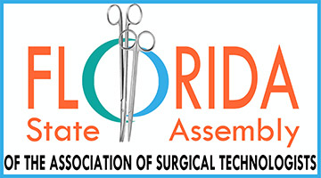

“Tech Talk in Tampa”
Meeting Agenda
Tampa, FL March 9, 2019

7:00 am – 7:20 am Registration Desk Open

7:20 am – 7:30 am Welcome and Introductions/ President George Sasser

7:30 am – 8:30 am Expanding the Surgical Tech role beyond the OR:
Angie Drapeau, CST 1.0 CE

8:30 am – 9:30 am Lobbying for Mandatory Certification: Stephanie Whalum,
Esq. 1.0 CE

9:30 am – 10:30 am Breast Cancer Care & Treatment Charles Cox, MD 1.0 CE

10:30 am – 10:45 am Break

10:45 am – 11:45 am Seeking Recognition/Public Awareness of CSTs:
George Sasser, CST 1.0 CE

11:45 am – 12:45 pm Lunch

12:45 pm – 2:15 pm OR Etiquette and Finding Your Voice: Sonia Gainer,CST
1.5 CEs

2:15 pm – 2:45 pm Business meeting/Elections

2:45 pm – 3:00 pm Break

3:00 pm – 4:00 pm The Ins and Outs of State Assemblies: Kim McDuffie, CST
1.0 CE

4:00 pm – 4:45 pm Election results – Program Wrap Up/ Q & A with the FSA
Officers

Florida State AssemblY

Annual Business Meeting, BOD & Delegate Elections, Workshop

March 9, 2019
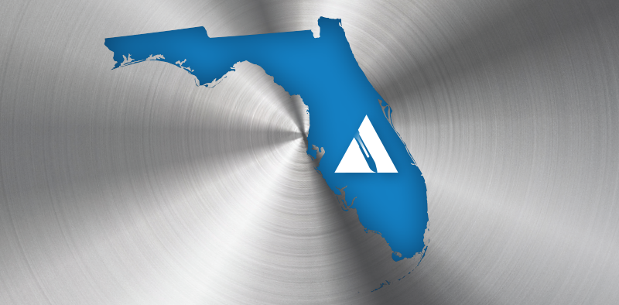
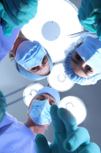 |  | WE NEED YOU!  All BOD Positions Open  2-YEAR TERM: 2019-2021  President  Vice President  Treasurer  Two (2) Directors  1-YEAR TERM: 2019-2020  Secretary  Three (3) Directors  Also, delegate elections for the 2019 AST National Conference in National Harbor, Maryland  More info at http://www.floridasurgicaltechs.org/  EARN 7 CE CREDITS
Support your profession, we need your voice and talent!
Location
Quality Inn, 2701 E Fowler Ave, Tampa, FL 33612

More Information Contact
Jo Lana Cota at 561-602-9256, cotaj@palmbeachstate.edu
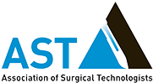 |  | Florida State Assembly  PO Box 600961, Jacksonville, FL 32260-0961  http://www.floridasurgicaltechs.org/

